SURVIVAL OR EXTINCTION

by
KEVIN MUGUR GALALAE

PART ELEVEN
COUNTRIES ARE PRISONS

(PART ONE: LIFE OR DEATH; PART TWO: FOLLOW THE MONEY; PART THREE: NEED NOT GREED; PART FOUR: TAMING THE WOLVES; PART FIVE: DISCARD ME NOT; PART SIX: HEAD AND HAND; PART SEVEN: POWER OF MONEY; PART EIGHT: BURDEN OF RESPONSIBILITY; PART NINE: CONCEAL AND DECEIVE; PART TEN: CRISIS OF LEADERSHIP)

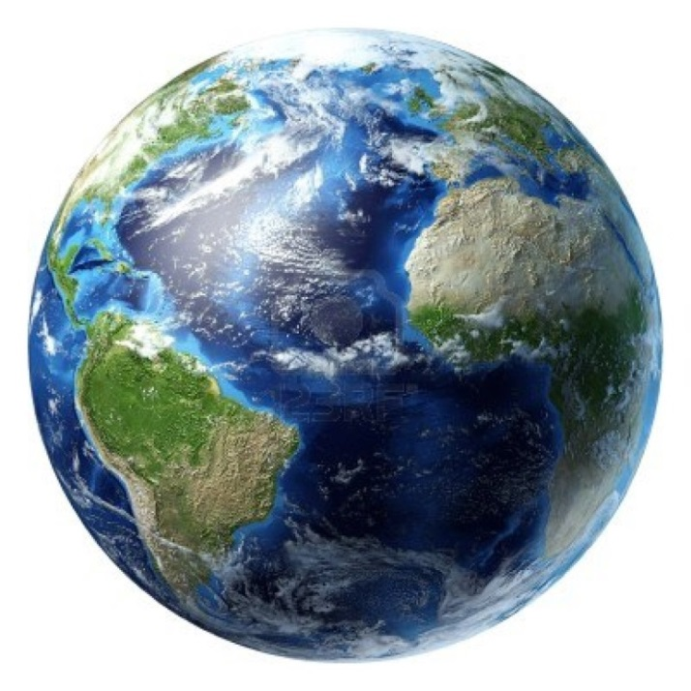
Do you see any borders?

I don’t.
All I see is continents and oceans.
Borders don’t exist. They are just imaginary lines that restrict our lives to a social construct called the nation state; a construct that dates back to the 17th century, and more often than not only to the 19th century, has long outlived its time and usefulness and stands in history’s way.
Nation states block the natural evolution towards ever greater social and economic organizations, the last of which must be global in size and scope, for it alone can enable us all to access and use the world’s unequally distributed resources, to mobilize the entire panoply of human talent, to utilize the advantages of each and every geographic and climatic condition, as well as minimize their disadvantages, to address environmental pollution and, most importantly, to keep peace on earth.
In chapter nine I used the analogy of the human body for our nascent global civilization and of the cardio-vascular system to describe the economic activity by which we meet our material requirements. I will now take this analogy a step further by comparing the disparate socio-economic systems of every country on earth, which have developed largely in isolation over the course of centuries, to different blood types. The isolation has disappeared in the last century due to the lack of physical space to expand into, the absence of undiscovered or virgin continents, leaving us no alternative but to grow into one another, trade with one another, share with one another, and in so doing coexist with one another, having learned the hard way that taking by force from our neighbors leads to destruction and chaos and cruelty.
But as our interdependence deepens, our socio-economic differences show us just how incompatible we are because we lack common rules and common denominators, just as incompatible as different blood types would be in a blood transfusion. Yet a global economy and a global architecture require the same lubricant just as surely as a human organism requires the same blood type. And as our disparate and different countries come together economically and culturally ever closer, our different blood types are being forcibly mixed, despite their incompatibility, and until such time as the mixing is complete and a state of compatibility is reached our global civilization will be sick because the different nation states that are being forced together by necessity are in a temporary state of mutual rejection.
In addition to this lack of compatibility, as our advanced science and technology demand ever larger and more complex forms of organization and specialization and coordination, every culture and every economy on earth have to dance according to the music of our machines and industrial processes, which we have devised to make our lives easier, our labors less repetitive and backbreaking, and our efficiency greater so that we can have more things to enjoy and more time to do so.
So it is not only that our disparate cultures and economic systems are coming together as one despite their lack of compatibility, but also that they are advancing in step with the science and technology driven by human ingenuity, ambitions and dreams, which are the fuel and engine of progress and depend on increasingly larger and deeper systems of cooperation and coordination.
When you walk you need no one but yourself and a good pair of legs. When you ride a horse you need saddle makers and blacksmiths. When you drive a car you need miners and minerals, roads and road builders, engineers and mechanics, oil and rubber, and thousands of industrial processes and manufacturing plants in order to make a car and maintain it, operate it and have roads to drive it on. And when you fly a plane the requirements are even greater and are not only technical but also political since traveling by plane means crossing the air space of multiple countries and that requires permission, agreements, a global infrastructure of airports and traffic control towers and the ability to communicate in one language.
When you travel on foot your world is small, no larger than your feet will get you in a single day of walking, say 25 Km, and simple, as simple as deciding to put on your shoes and get going. When you travel on horse your world is accordingly larger, about as large as a horse can carry you in a single day, say 100 Km, and as simple as harnessing your horse and throwing a saddle over its back, but no longer so simple that it involves only yourself for now you depend on a beast of burden and the beast of burden in turn depends on you. When you travel by car your world is substantially greater because a car can easily take you 1000 Km from home in a single day, but also substantially more complicated because you have to use a system of public roads and abide by the established rules of traffic and depend on the availability of fuel along the way, thus on millions of other people, their labor and on a system to coordinate it all. And when you travel by plane your world is your oyster because you can get anywhere on earth in a single day; provided that the system is in place to facilitate international travel. Yet no such system can exist without international cooperation and common rules; cooperation and rules that have been fought for and argued over for decades and that can only stay in place so long as the world agrees to abide by them and so long as peace and stability reign so that nothing and no one can disrupt this complex and sensitive system of which we are all a part of one way or another, whether we like it or not.
What we have gained in speed and distance and comfort we have lost in simplicity and independence.
Everything has a price. But once you have travelled by plane there is no going back to the days of the horse and buggy. Just as once you have used a cell phone there is no going back to the days of the town crier. Just as once you have seen a movie there is no way you will be content with a puppet show.
And just as we have all come to depend on this system that keeps these modern wonders going so this system depends on us, for we are the wonder makers. It is our labors, our ingenuity and our cooperation that makes modern wonders possible and set us above the beasts and aside from God. They make civilization possible and civilization in turn makes us civilized. The cost we have to pay for civilization, however, is loss of individual freedom, because civilization demands that we think of the system and not just of ourselves and that in turn requires that we all have a place within the system. As we serve the system, the system must serve us.
The system, however, is no longer serving us. We have become subservient to the system. The system itself has become our master. And until and unless we seize control of the system and make it once again subservient to human needs, we are doomed. To make the system subservient to human needs we must as individuals rise above the system and subdue it. A system that is out of human control is a monster, a beast. And that is the present state of the system for it has slipped out of human control. The system has acquired a life of its own and is, as a result, dehumanizing.
The system has slipped out of human control because no human being or body of human beings exists who has the authority to be in charge of the world and the world is, as a result, at the mercy of national authorities that are incapable of coordinating a global plan of action, which is why our civilization is spinning out of control.
Every industry and every interest is moving into a direction of its own and tearing the world apart. The international community, embodied by the United Nations and its agencies, has jurisdiction only over international security prerogatives but lacks a trim and effective body of outstanding individuals who are authorized to impose their will on national assemblies by dictating specific goals and targets with respect to population control and resource sharing, which are the two international security prerogatives on which our survival and our future depend, but that have yet to be brought out in the open because they clash with narrow national interests and offend cultural or religious sensibilities.
We have run out of time and space for trial and error or for laissez faire. Humankind is simply too destructive on the natural environment and too great a burden on Mother Earth because there are too many of us, we are multiplying too fast and are consuming more than the earth can give, which means that we live unsustainably.
Our elected governments have been waging war on our reproductive systems since 1945 to ensure we live within our national means. More recently, they have been waging war on our very lives to ensure that the demographic transition they have started six decades ago is accomplished before the lopsided population pyramids they have caused do not collapse and in this fashion humanity reaches sustainability rather than self-destruct.
Democratic governments, as it turns out, are the most murderous and treacherous, as they covertly commit structural violence on their own citizens that is far more damaging and extensive than the violence committed by non-democratic governments such as China, who has been honest and blunt with its citizens and has proceeded openly and legally to do what is necessary and halt its population growth before the country outgrows its resources. No such honesty has been forthcoming from the elected governments of democracies, which have instead chosen to commit genocide in order to preserve the illusion of democracy and the pretense of the rule of law.
Once this becomes public knowledge, the affection people feel for their beloved countries will evaporate virtually overnight. People will also realize that the only way they can safeguard their rights and liberties, their very lives, and the continuation of their genetic lines into the future is by gaining control of the political process at the global governance level, thus by democratizing global governance, where the international security prerogatives of depopulation and globalization that truly shape every aspect of our lives are being pursued behind closed doors without our knowledge or consent.
By insisting on preserving the illusion of national self-determination at a time in our history when the material and environmental circumstances are so grave and dire as to dictate that we embrace a global social construct, for that is the only way we can address global problems, we have condemned ourselves to a slow death behind the walls of our nation states. We live in prisons of our own making and there is no escaping from these prisons unless and until we comprehend why we need to free ourselves from the artificial differences and separations kept in place by the world’s 195 nation states.
There can be no national sovereignty on the issues of population control and resource sharing, which have long been designated international security prerogatives and on which not only global peace and prosperity depend but also the survival of human civilization and of life on earth. And since these two issues affect every aspect of our personal and national lives there can be no personal freedom and no national sovereignty, period, with respect to how many children we can have and who we choose to share the world’s bounty with.
The circumstances dictate only one possible two-pronged solution: a global one-child policy until such time as we reach a sustainable global population, at which point a global two-children policy will take its place in perpetuity, and the total elimination of national borders to facilitate the equitable distribution of the world’s wealth and resources and enable the widest range of individual rights and freedoms for all the world’s people.
Those reluctant to abandon the nation state object on two grounds: fear for their culture, which could be strangled by homogeneity the way franchises have destroyed entrepreneurship, and fear of tyranny, lest it becomes global and can never again be escaped. But culture does not need country to thrive, on the contrary. And an effective system of democratic checks and balances rooted in the ethnic and cultural diversity of the entire world and freed from the shackles of narrow and competing national interests is far more likely to be stable than the current national democracies.
Once the dictates of national governments disappear, cultures will be able to breathe freely and express themselves locally and regionally unencumbered by rules and norms imposed by the most dominant ethnic group within each nation state. Cultural differences will in fact thrive and multiply in a borderless world where geographic and climatic conditions are not trumped by national political considerations. And in time, the most attractive aspects of various cultures will spread globally and combine and intermingle in ever-changing ways until a global culture emerges a few centuries from now that will be the sum total and the best mixture of the disparate cultures now present on earth. Politics will no longer interfere with the organic process by which cultural syncretism allows human groups to change, borrow and evolve.
Similarly, the likelihood of political tyranny begetting a global police state, which is what we now have in effect because the elites have banded globally and condemned the rest of us to annihilation, would in fact be minimized not increased by a federation of autonomous states subsumed within a global democratic government that leaves only two issues, depopulation and resource sharing, outside the control of the electorate. And the two issues divorced from the will of the people could not be misused and abused for political ends because they would be addressed openly and under the constant and full scrutiny of the public, so that every decision is justified by the facts on the ground and thus depoliticized.
The faster we consign the nation state to history the better we can use the world’s bounty, the quicker we can eliminate fear and want, and the greater will be our rights and freedoms as citizens of the world. But to consign the nation state to history we must agree on a set of global common denominators that can serve as the foundation on which to build a global society and that provide a step forward in every respect: social, economic and political. The OM Principles do just that.
And OM Principle nine, entitled ‘open borders’, shows how the economic interdependence the international community has pursued since 1945 must now advance into political unity.
PRINCIPLE 9
OPEN BORDERS
Every nation that chooses to be governed according to the principles of OM will immediately open its borders to allow the unrestricted movement and resettlement of people regardless of their origin as well as unrestricted trade with nations that reciprocate in full the practice of free and fair trade. Never again will capital enslave labor by taking advantage of national or regional differences to exploit the working man and to shackle him in economic bondage.

Behind the apparent simplicity of the open borders principle lie three demanding preconditions: a set of common global denominators, the unrestricted movement of people and goods across frontiers, and equal pay for equal work regardless where on earth that work is accomplished. The European Union and the United States of America before it have shown that the elimination of frontiers is not only possible but also desirable, even when these three preconditions are not fully met.
The free trade agreements that are being pushed with desperation by policy makers the world over, while painful are absolutely necessary if the power of economics, which is the expression of material needs – the only needs humanity cannot ignore for long – is to make possible the eventual implementation of the three preconditions of an open borders society even in the absence of political will.
Several proud and long-standing nations, are reluctant to give up their self-determination and control over their resources, which amounts to an abdication of sovereignty, and that is where we see today’s resistance points: the Ukraine, Russia, Iran.
But these nations, rich in history as they are in resources, must come aboard the international community otherwise the world will not be able to feed, house, clothe, educate and transport the 2 to 3 billion people that will be born into the world between now and the middle of the 21st century, when the population is expected to peak due to extraordinary hidden efforts since 1945.
At 17 million square kilometers Russia is by far the largest country in the world, covering more than one-eighth of the Earth’s land mass. Its oil, gas, and mineral resources are the largest in the world and indispensable to the world, which is why they must be shared with the world’s 7 billion people and not monopolized by Russia’s 143 million inhabitants. The Ukraine, the breadbasket of Europe, is one of the few countries in the world that produces an agricultural surplus and now more than ever the world needs to still the hunger of billions. It already produces a quarter of all agricultural output of what used to be the former Soviet Union and uses only half of its arable land. The world cannot survive the next 30 years without Ukraine’s fertile soil and latent agricultural potential. And, of course, Iran is crucial to the world’s energy security because it has the largest natural gas supply and the fourth-largest proven petroleum reserves in the world.
Russia knows that if Ukraine falls it too must fall. Iran knows that if Russia falls it too must fall. And while no country on earth can hide behind the isolationism of nationhood at this time in our history when our overwhelming numbers place unbearable stress on global resources, neither should the last remaining independent nations cede their sovereignty without insisting that the global economic system that makes globalization and peace possible does not eliminate the financial excesses and obscene personal wealth that is currently so extreme as to destabilize the entire world and to corrode societies from within.
Material considerations are the most immediate and unavoidable which is why economic interdependence is the best way to unite the world and why monetary coercion has replaced military force as the means by which to keep every country in line and all human resources focused on constructive rather than destructive ends. Economics is the strongest political argument in a world divided. But an economic system that allows bankers and CEOs to earn 600 times more money than their employees not only loses its political strength it also becomes a political liability.
Political ideologies and religious world views and dogmas stand in the way of unity around common denominators, even among the elites, which is why they have united under the only banner that remained, economic self-interest and personal profit. But by taking advantage of their privileged positions within the coalescing force of economics they have discredited economics as a divisive rather than a uniting force. Russia, Iran, the Ukraine, and the other few nations that have refused to give up control of their natural resources to the global corporations that abuse the advantages they were given by policy makers in order to forge economic interdependence have the unique opportunity to return economics to the people so that it serves all our material needs and not just those of a self-serving minority.
As such, Russia and Iran – the last remaining sovereign nations – must make the abdication of control over their natural resources from national political bodies to global corporations that are a-national conditional upon the strict limitation of the personal incomes of the highest earners within corporations to a proportion that is no higher than ten times that of the lowest earners, as outlined in OM Principle one. In this fashion, the vast power given corporations by policy makers in order to accomplish global unity through economic interdependence can be taken back once global unity is concluded in the last act, namely the entrance of Russia and Iran into the global community.
Breaking the existing national structures to build a global one is an absolute necessity that not even a nation as powerful as Russia can ignore or resist anymore. Resistance is futile because brutal geopolitical and material realities force us to unite and to retire the nation state, which is a social construct that is too small to protect its citizens, as it is powerless in the face of these brutal realities. Not only is the nation state too small, it is also too short-sighted.
The needs of individuals, the needs of countries, and the needs of the world are completely different and move according to different timetables. The individual wants satisfaction here and now. National assemblies have a few years. But the world thinks in centuries. The geopolitical issues of population and resources require that we think in centuries and plan and act with objectives in mind that are beyond our lifetimes and therefore cannot be subjected to the short-sighted choices of voters and their elected assemblies. These objectives are of existential importance and cannot be jeopardized by the narrow interests of nation states and the terrible polarization that fractures the world according to ethnic, cultural, political and economic lines of division. For all of the above reasons the nation state must be retired and democracy bypassed if we are to limit our numbers to a sustainable level and make sure that there is enough for all and that we leave enough for future generations. These are the irrefutable arguments at the policy making level that compel us to dissolve the nation state.
At the personal level, why would we want to restrict ourselves to the borders of single countries when the entire world can be ours? Why would we want to limit ourselves to the dictates of national bureaucracies when the earth is our home and nature our only master?
Do you want to live in this?
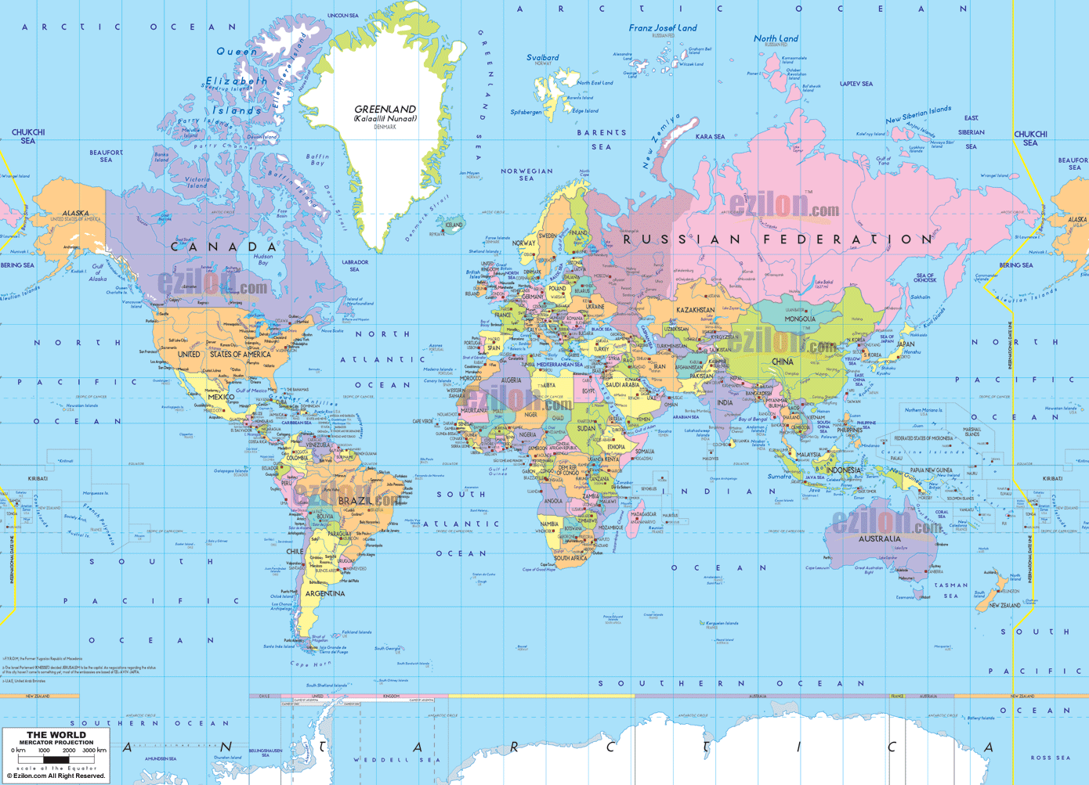
…or in this?
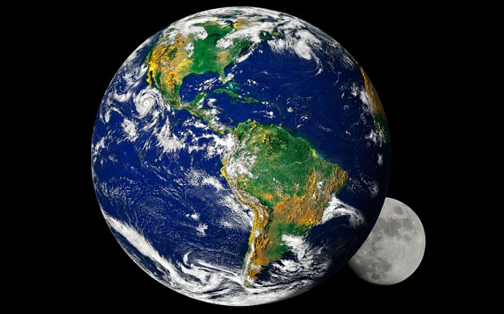

If you would rather have the entire planet as your home than just a measly country then let us stop perpetuating differences, real or imagined, and start finding common ground, real or imagined; for the latter course of action leads to love and peace while the former leads to war and hate.
All boundaries are conventions waiting to be transcended.
So let us transcend them.

